PowerTeacher Gradebook Procedure on How to Take Attendance

- Access the website address: http://powerschool.gdoe.net/teachers. Login using the assigned Powerschool Teacher Userid and Password.

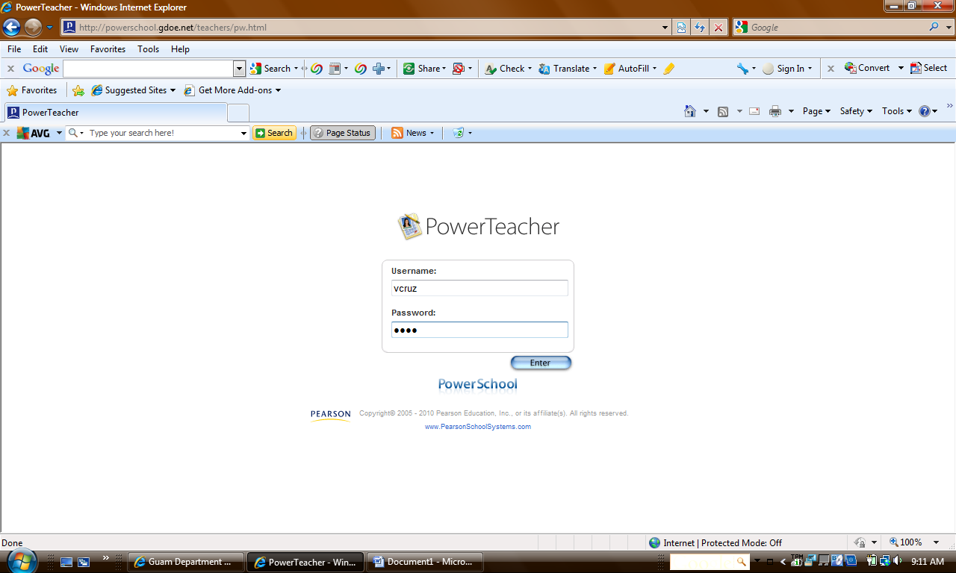

- Click on the Chair icon.

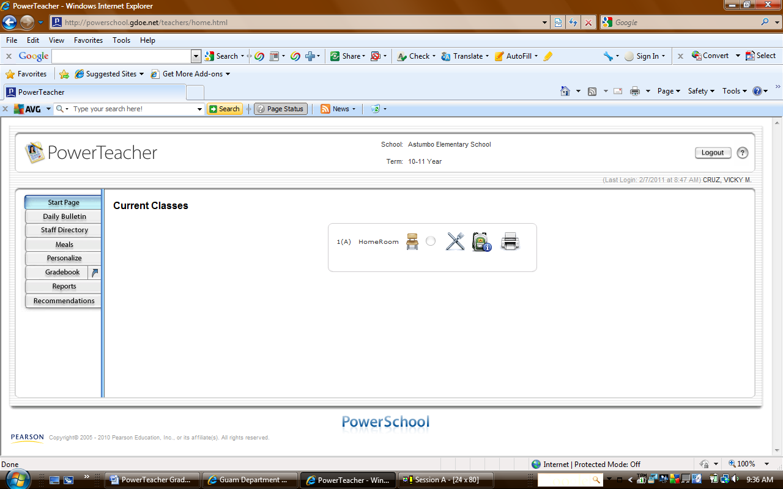

- Verify the attendance date in the Record Meeting Attendance box .

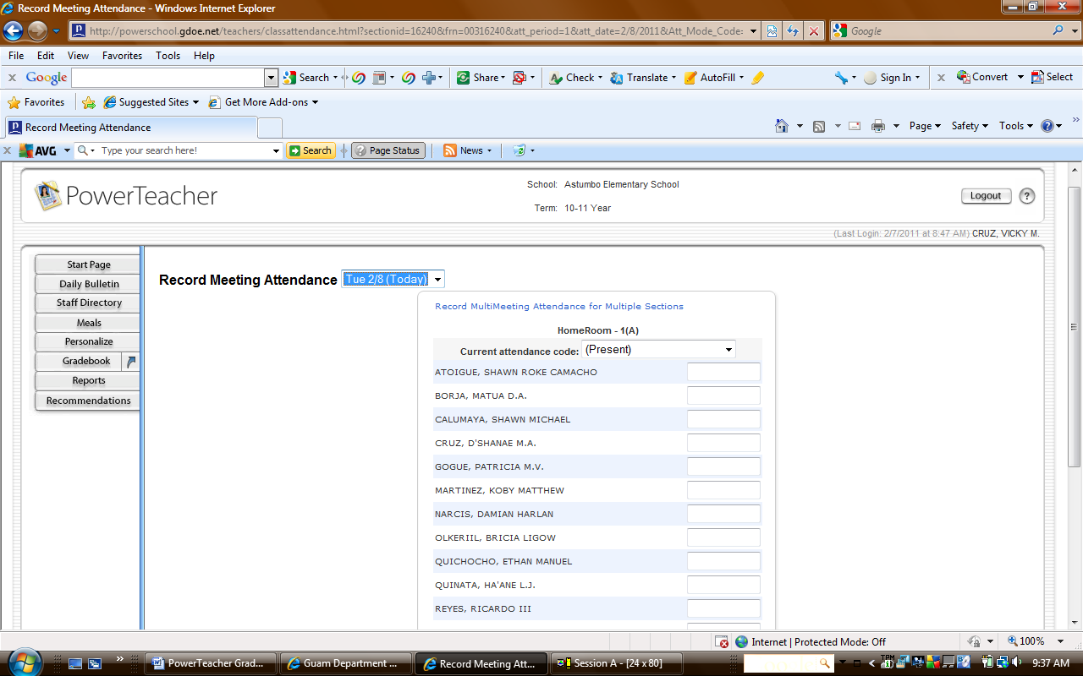

- Select the attendance type that will be applied to the students by clicking on the arrow down in the Current attendance code box.

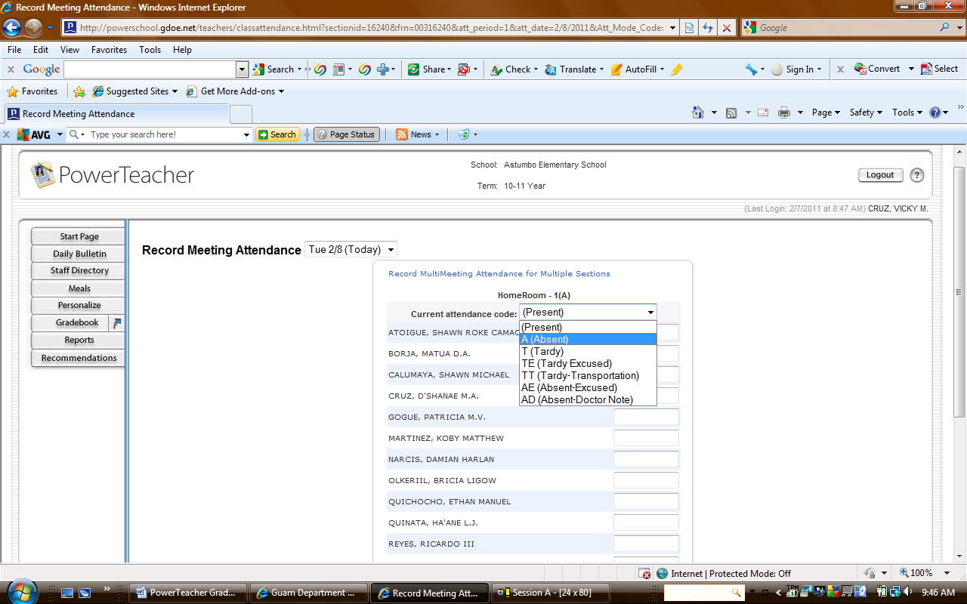

- Click in the box next to the student the selected attendance code applies to.

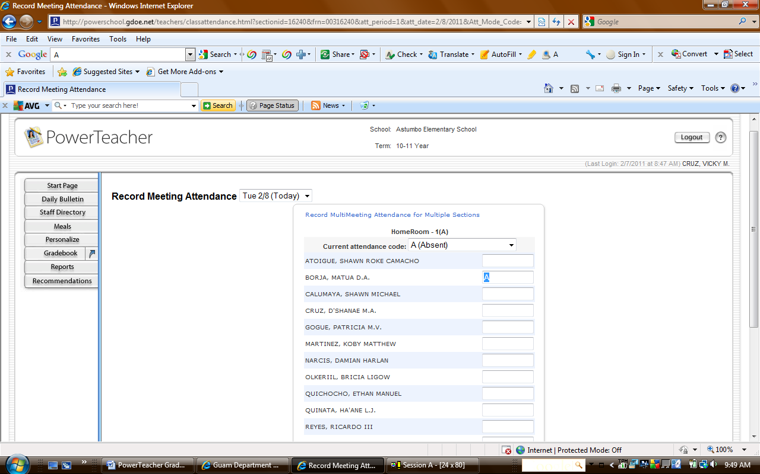

- Click the Submit button when done taking the student’s attendance.

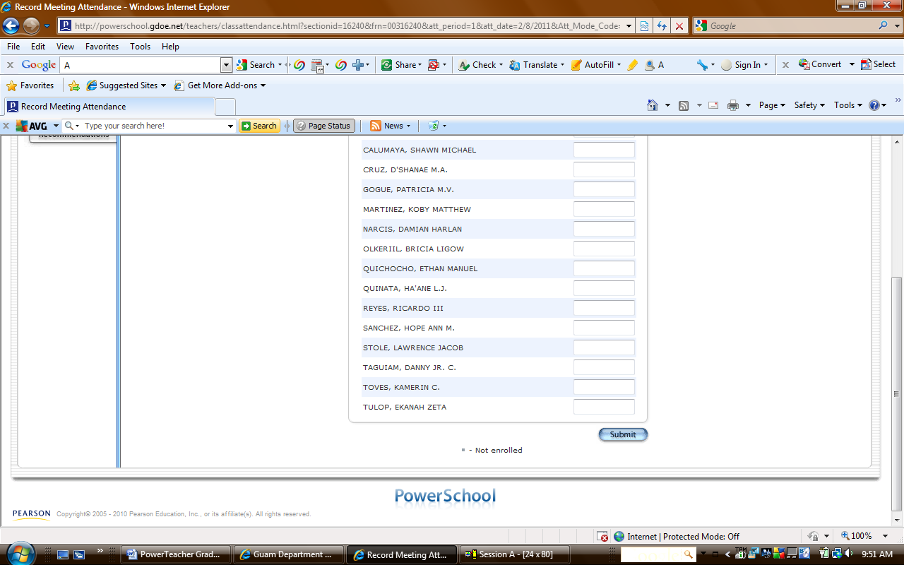

- The circle next to the chair icon turns green to inform the system that attendance was taken.

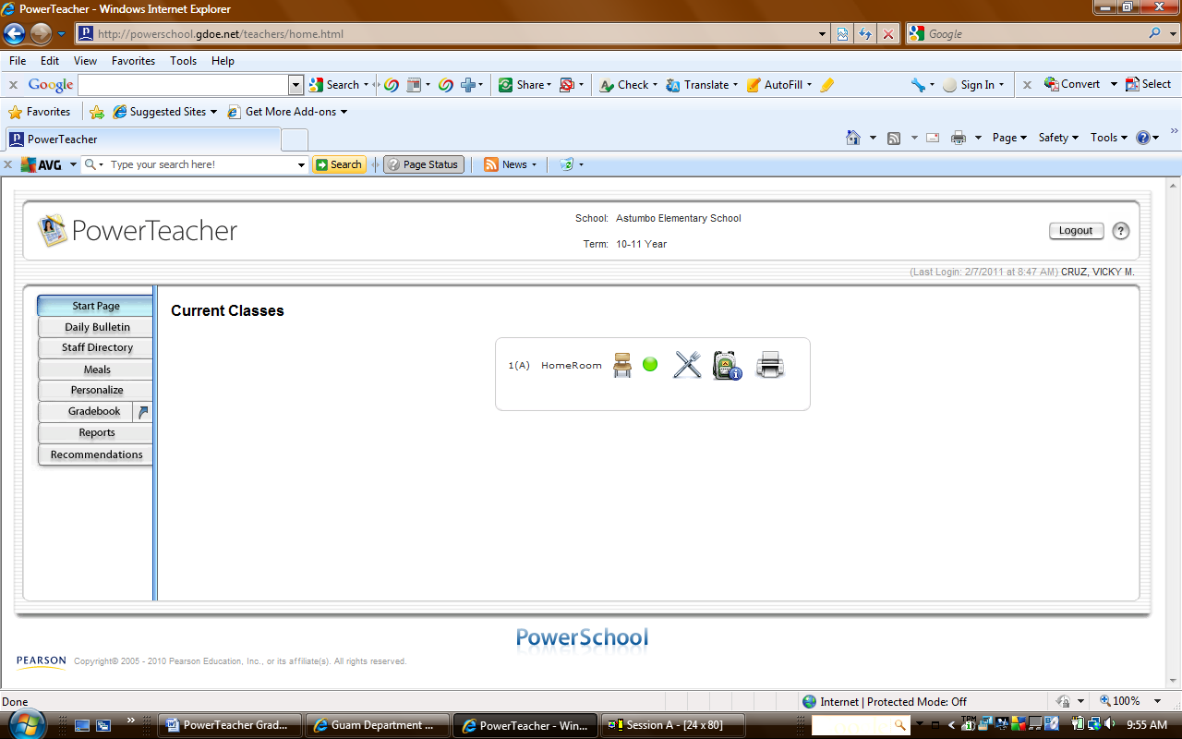

- Click on the Logout button to exit the PowerTeacher Gradebook.

